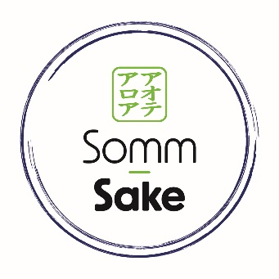
HOST RESPONSIBILITY POLICY 2023
As a responsible producer and supplier of alcohol, we have a social and legal obligation to create a safe environment for everyone. Our website promotes drinking in moderation and our Hospitality training and Sommelier courses include associated food recommendations to match Sake consumption.
For our online sales the management and staff of Somm-Sake take steps to ensure only customers over 18 order from the website, we do this by having a gateway into the site that requires a declaration of age and again at the point of purchase. In addition, the courier service we use requires a signature from customers who are over 18 yrs.
For our training courses the management and staff of Somm-Sake have a responsibility to provide an environment that is not only comfortable and welcoming but also where small samples of alcohol are shared responsibly as part of your training package. We have therefore implemented the following Host Responsibility Policy.
- We provide a range of non-alcoholic drinks whilst you are in class.
- We also use lower-alcohol Sake products encouraging students to consider these as alternative products for their business’s.
- We encourage our students to enjoy the delicious food on offer at the training venue where we are delivering a course.
Please see menus available in the venue we are presenting at or visit the “Taste Zone” of the event following signage located throughout the premises.
- It is against the law for us to sell or supply alcohol to minors (under the age of 18 years). If we believe our guests are under the age of 25, we will ask for identification.
Acceptable forms of proof of age are:
- A current NZ driver’s licence
- The Hospitality NZ 18+ card
- Valid passport.
It is against the law to allow smoking within an internal area of a licensed premise. We take all practical steps to ensure our guests do not smoke within our indoor premises. We encourage our guests to use the designated outdoor area provided.
- Our staff have your safety and enjoyment in mind. They are trained to deal with anyone who may become intoxicated and will politely intervene to prevent them from becoming a danger or nuisance to themselves or others. Guests who are visibly intoxicated will not be served alcohol and will be asked to leave the premises and encouraged to take advantage of safe transport options available.
- We promote several transport options to get you safely home. Please ask us for further information. We encourage guests to designate a sober driver before arriving at our premises. We will offer the designated driver a complimentary non-alcoholic drink of our choice for being responsible of their group’s safety home.
We will make sure all these services are well promoted and will display the necessary signage required under the Sale & Supply of Alcohol Act 2012.
- We maintain a training and management policy to give our staff the skills and support they need to do their job responsibly.
Please be our guest and take advantage of the services we offer. Host responsibility makes sure that everyone has a good time, and leaves in safe shape for the trip home. It could save our licence, and it could save your life.
Thank you for visiting Somm-Sake at a lifestyle expo or private event.
We hope you enjoy your time with us, and we look forward to seeing you again soon.
THANK YOU

